CS 340 README Template

About the Project/Project Title
This project is a scenario for Global Rain, a software engineering company that specializes in custom software design and development. The team is tasked with a project for an international rescue-animal training company Grazioso Salvare. This project is aimed at creating an end user application database for Grazioso Salvare, in which they can keep track of animals they work with.

Motivation
Grazioso Salvare identifies dogs that are good candidates for search and rescue training. These dogs will be able to find and help rescue humans or other animals in life threatening situations. Grazioso Salvare is seeking an application that can work with data that they already have from animals shelters to be able to identify and categorize available dogs.

Getting Started
To currently run the program you will need programs listed under “Installation” section.
Within MongoDB, the database AAC needs to imported. Also, users need to be created for the program to run outside of the terminal or command prompt. The users created were an administrator with full read/write ability, and a user called “aacuser” that had also has a read/write ability.

The Python driver for Mongo that was used was PyMongo, and it was chosen for a few different reasons. First and foremost, PyMongo provides the methods for CRUD, which is the essence of the module created for this project. Secondly, PyMongo is made specifically for working with MongoDB, which is the database used. In the Create function, the user can add an entry, or document, into the database with as much information available, in which it will be stored for later retrieval. The Read function, will search for a certain item in the collection by a key/value pair (i.e. {“name” : “Meeko”} ) If found, it will return the entry (or entries) in JSON format. Next, the Update function will search for an item by a key/value pair, and edit it to change data within the entry. If successful, it will again return the entry in JSON format. Last, the Delete function will delete an item by key/value pair and return the key/value pair to reassure the user that it had in fact been deleted.
The Python driver for Mongo is topped with a user-facing dashboard created with the Dash framework. Dash is an open-source framework of Python used specifically for building analytical web applications. In this project, a lot of data is used; therefore, Dash helps organize and present the data for an ease-of-use and navigational experience to the user.

Installation
Jupyter Notebook @ https://jupyter.org
MongoDB @ https://www.mongodb.com/docs/manual/installation/
Dash @ https://dash.plotly.com/introduction

Usage

Code Example
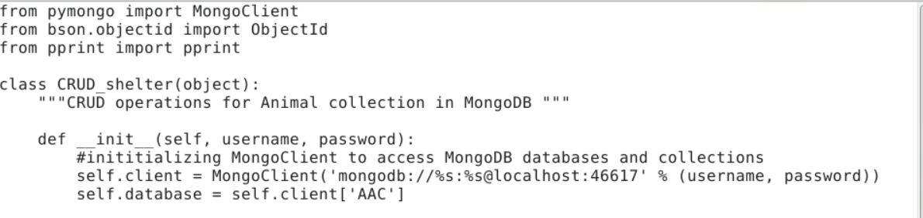
The code starts with importing the MongoClient from PyMongo, and a declaration of the class CRUD_shelter and __init__ function to connect to the database.

Tests

Testing the code start with the two first kernels pictured below. One being importing the module, and the other as some variable declarations.
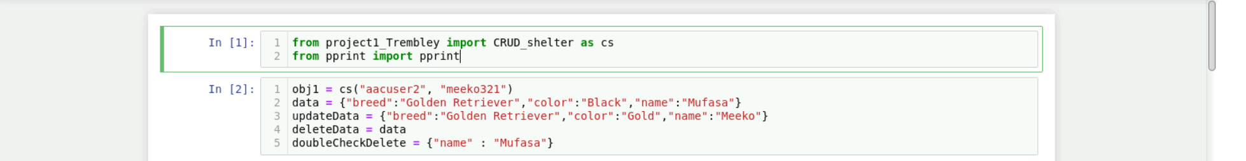
Next, there we can test out the CREATE method by passing the ‘data’ variable

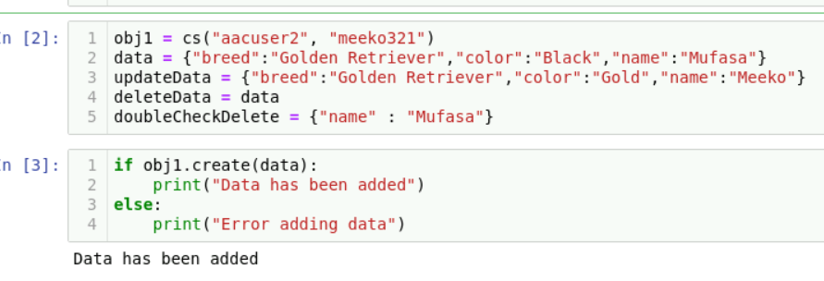

After ‘data’ has successfully been added, we can call the READ function by searching and outputting results based on a key/value pair

Once we can see the output of the READ function, we can try the update function. This is done by inputting the collection document we would like to update(based on a key/value pair) with the data we will update it with. The function will then update each appearance of the “data” variable with the “updateData” variable.
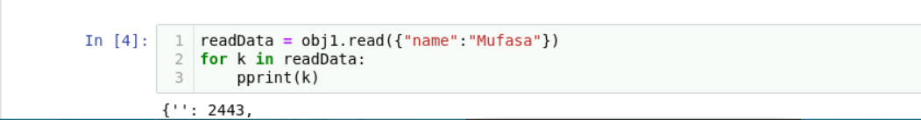
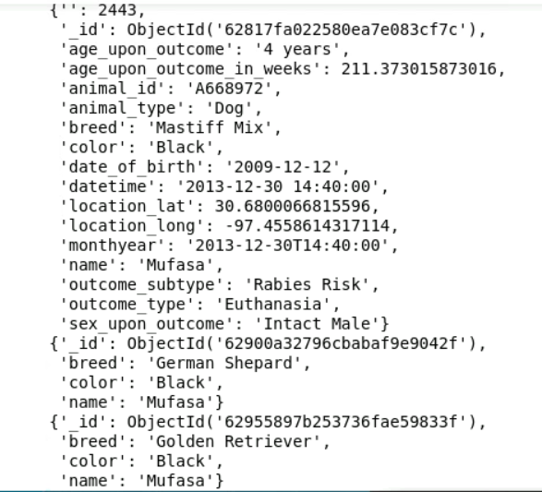
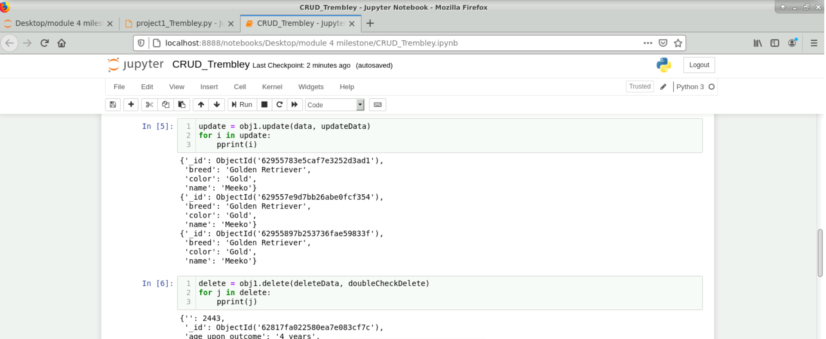

Last but not least, we use the DELETE function, which will remove the entry from the database, and return the key/value pair to verify that it is missing and has been deleted.

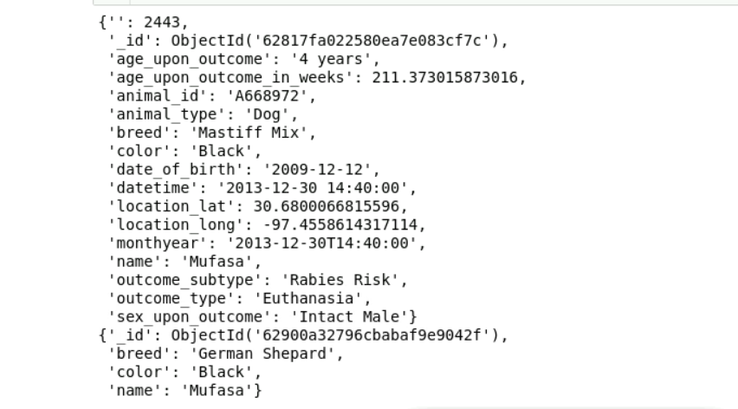

Below are screenshots of different snippets of code that are vital to the program. Although all the code is technically vital, what is depicted below is the basis of it all.

Importing of all the libraries used in the program
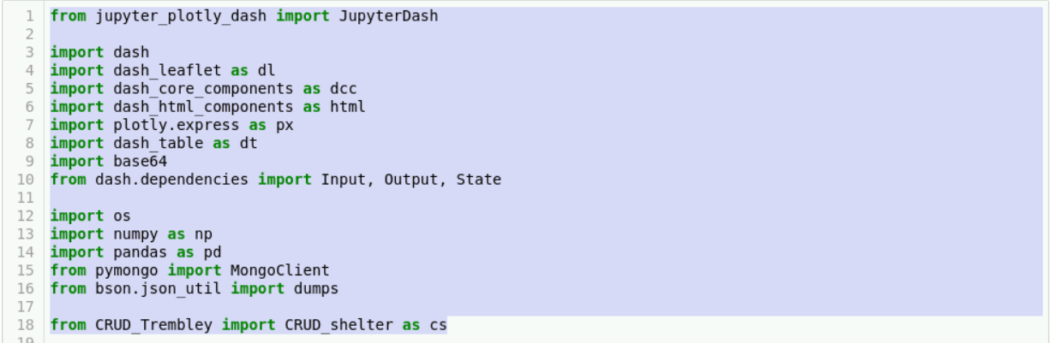

Initializing the logins to the database(found under Screenshots).
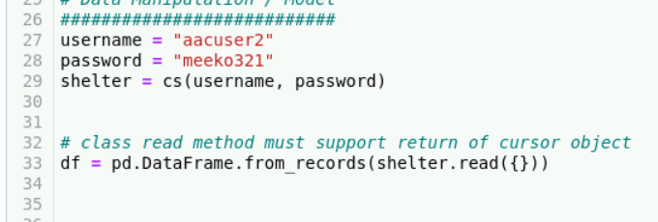
The basic layout of the program, more specifically the radio buttons.
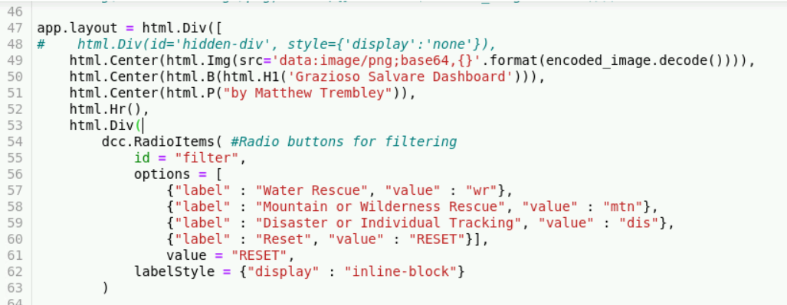
Sample of 1 query – Water Rescue. The main challenge for myself here was adding the specification of the age_upon_outcome_in_weeks. I struggled for a bit, but my issue was being syntactically incorrect. Once I reviewed the documentation for MongoDB and querying again, I was able to get it to work successfully.
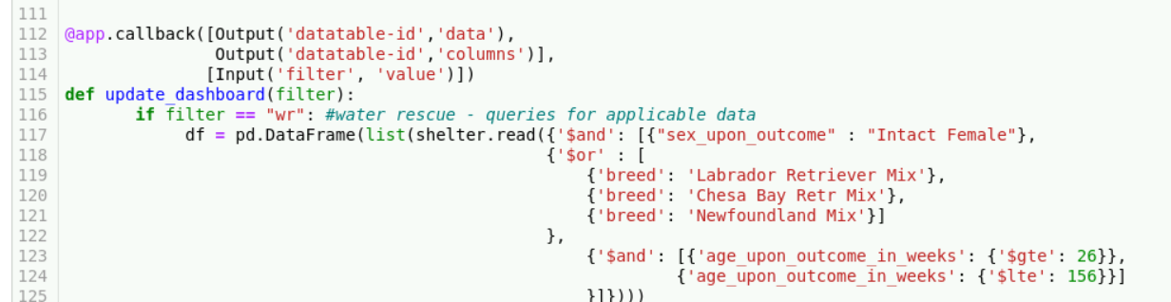

Geolocation map – main difficulty for this was to let it dynamically change depending on which query was selected. Realized it just needed to be told what the data table was displaying, and it could change based off of that information.
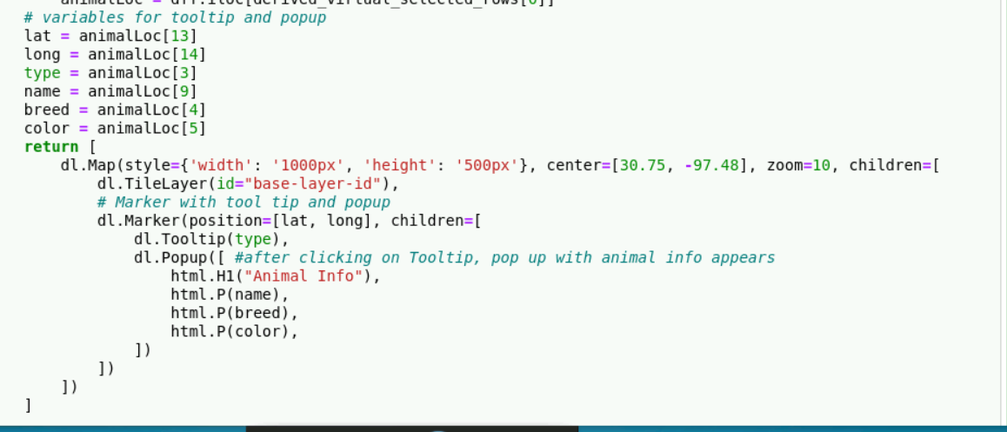

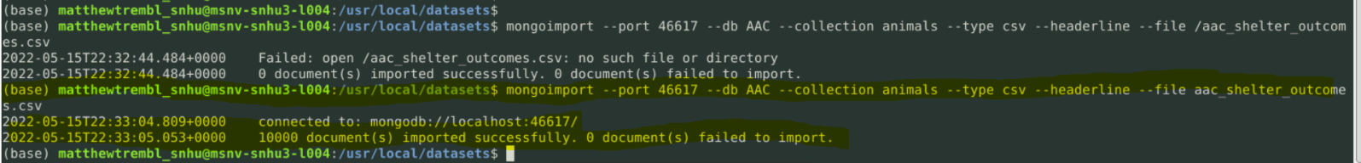
Screenshots

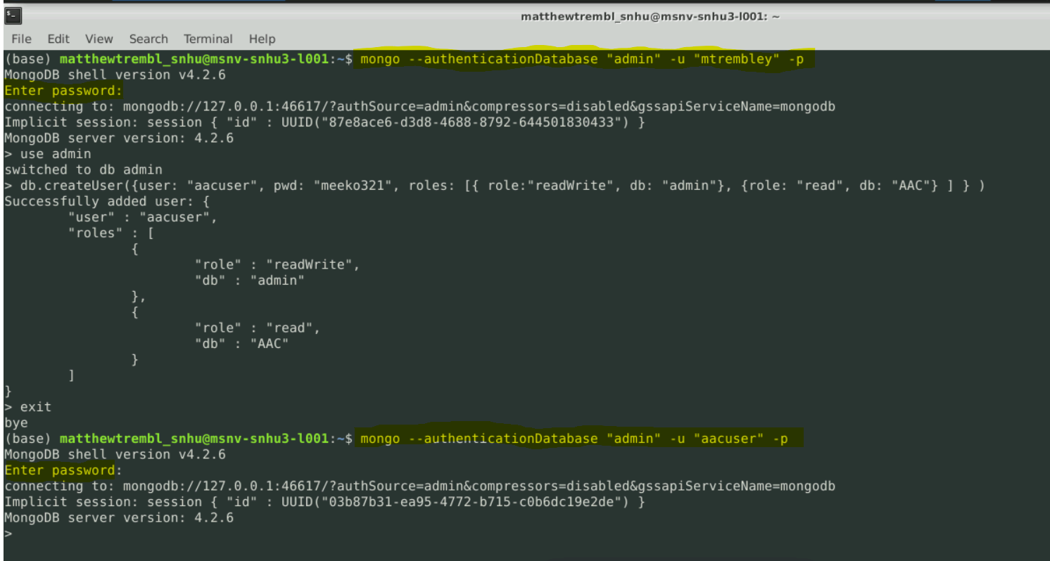

Contact
Matthew Trembley

matthew.trembley@snhu.edu

